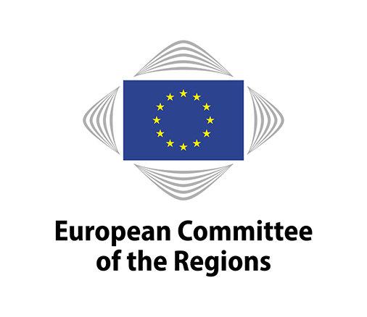
EN

Brussels, 8 November 2018

21st SEDEC COMMISSION MEETING

- 27 NOVEMBER 2018 -

AGENDA ITEM 5

COR STUDY - ADDRESSING BRAIN DRAIN: THE LOCAL AND REGIONAL DIMENSION

DEBATE WITH SIMONA CAVALLINI, FONDAZIONE FORMIT

Executive Summary

The free movement of workers, one of the fundamental rights of European citizens, has facilitated intra-EU labour mobility. However, in some regions (‘sending regions’) this freedom has led to a significant out-migration of their highly educated workforce to the advantage of other regions (‘receiving regions’). This is determined by the growing competition for talent and the limited capacity of sending regions to create attractive conditions for these workers. Local and regional authorities (LRAs) in sending regions have to cope directly with the socio-economic effects caused by the significant loss of talent or brain drain. Addressing these effects may require the formulation of appropriate policies and/or measures to retain, attract, or regain highly educated workforce.

In 2017, there were almost 17 million EU28 movers, of which about one-third (32%) were in the 15-34 age bracket. The majority of EU28 movers head to Germany and the UK, which are also the two top destinations for younger (15-34) European movers. Top countries of origin are Romania, Poland, Italy and Portugal (EC-DG EMPL, 2018). In 2017, 25% of EU28 movers of working age (between 15 and 64) had tertiary level education. These highly educated European movers favour urban settings and northern areas of the EU (Sweden, Ireland, Estonia, Denmark as well as several regions in the UK). They also usually enjoy high employment rates.

Using the data available, this study focuses on statistics at regional level regarding cohorts of young and of highly educated EU28 movers (Part 1). It then investigates successful local and regional level policies and/or measures used by LRAs to tackle brain drain in sending regions through the prevention of brain drain, the mitigation of brain drain, and the response to the negative effects of brain drain. It also looks at ways to attract or retain talent in receiving regions. This was done primarily by compiling an inventory of 30 initiatives undertaken by LRAs from 22 Member States. Twenty of these initiatives are described shortly in Part 2 of the study. The other ten initiatives are developed in the form of ‘case studies’ in Part 3.

In the final part of the study, recommendations for LRAs are drawn from these initiatives. These are aimed at LRAs in sending regions and focus on outlining measures/policies that have proved effective in some European regions. BEST PRACTICES By necessity, they are broad in nature since the transferability of these measures/policies depends on many factors: they range from a region’s policy development model (e.g. competencies of public authorities) to its contextual conditions (e.g. labour policy and regulatory framework, economic development, education system and demographic trends). In fact, there is a high correlation between the socio-economic conditions of a region and its brain drain/gain dynamic. Structural migration inflows, especially of young highly skilled individuals, usually occur in regions that have a comparative advantage and play a dynamic role in competing for international talents.

As a first recommendation, it is fundamental for LRAs in sending regions to become aware of the brain drain problem. LRAs should also identify the talent they want/need to retain, attract or regain. Various tools/measures can be used for this, ranging from SWOT and comparative analyses to surveys. Notably, establishing a dialogue with the talent in question appears to be essential. This is especially true for young talent. For receiving regions, these tools may also become monitoring instruments for measuring the satisfaction level of talent and for understanding whether their needs are being met.

A second recommendation relates to the need for the coordination of players and the synergies of resources to focus on talent-based growth strategies. These circumstances can be supported, for example, by regional Smart Specialisation Strategies. Examples of other valid instruments are physical spaces, virtual spaces, or quadruple/triple helix–based approaches/mechanisms. Coordination among relevant players is also intended to improve the local/regional matching of the demand and supply of talent. Similarly, it is intended to strengthen the talent-producing capacity of a region by nurturing its gifted youth.

A third recommendation relates to the opportunity to identify key driving sectors for retaining/attracting talent. Examples show that the targeting of promising sectors by LRAs does not necessarily relate to specialisation within the region. A fourth recommendation is to stimulate the absorption of talent from outside. This could be achieved by attracting international talent and/or regaining talent that had previously emigrated. It may involve the setting-up of specific projects or medium-term strategies as well as branding initiatives or initiatives aimed at rewarding talent.

A fifth recommendation is to work on the removal of structural impediments/barriers which may, for example, be related to infrastructure (e.g. physical and/or technological), services and facilities, the reputation of the locality/region and culture (e.g. gender-biased mentality). Finally, as brain gain automatically leads to competition for the same resource (i.e. talent), it is suggested that public authorities facing the same challenges should seek cooperative and/or shared solutions.

The sending/receiving status of a region can be viewed as dynamic and the evidence of this is an incentive for LRAs in sending regions to adopt an active approach to the intra-EU mobility of talent. Ad-hoc policies/measures implemented locally/regionally may increase a region’s visibility and/or create job opportunities for highly skilled workers and/or directly improve a regions’ attractiveness to talent.

_____________

